Setup Steps:

* In localhost/phpmyadmin
  + Create a Database with the name “ticdoc”
  + Import this Ticdoc.sql file and create the tables and data
  + 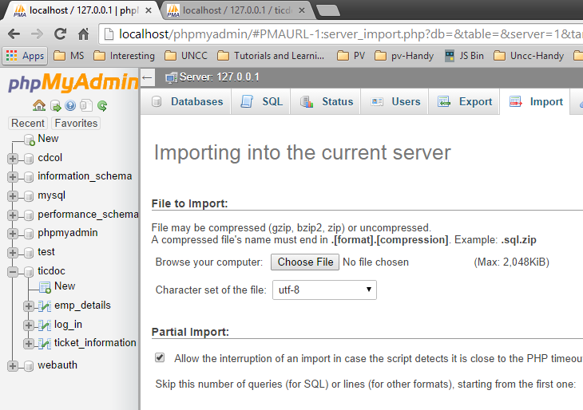
  + I haven’t setup any password for tomcat/mysql in xampp, so by default id should be “root” with no password
    - If you have any id, pwd setup in your system just include the same in login.php file in the necessary place.
* Extract the zip file contents and place the TicDoc folder in c:/xampp/htcdocs folder in your system.
  + (c:/xampp) is the directory where Xampp would be installed by default, if your have changed the installation directory, specify the same.
* In the browser hit the url “localhost/TicDoc” or “localhost/TicDoc/index.php”